Lesson 2:Dresses

Part A:File Naming

Okay so I promised we would do dresses but we still got a little extra to do. So fire up your girl .fla and .as. Oddly enough there not linked now... we should fix that.

Right Click on the ActionLayer and select Actions

The action frame will appear put your slaves name there EXACTLY like it appears in the file name for the .as in the include statement. Example “ #include "Slave-Menace.as" ”

Okay now that I have our two pages back to talking to each other lets add her to our copy of Slave Maker. Oops were going to need an image file now. Should be a nice cleaned image of your Slave.

Part B:Adding Your Slave to the Slave Maker program

Your SDK should have a file by the Name of “SlaveGirl4.txt” rename it “SlaveGirl1.txt” you can rename it to what ever number you want but since your going to be pressing it a hundred thousand times for debugging have it in the first slot. Remove or rename the copy of “SlaveGirl1.txt” from your copy of Slave Maker.

Lets open up the new “SlaveGirl1.txt”

Basically everywhere you see akane put your slave's name. Watch the capitalization. You can add the flavor text later on if you feel like it.

well that's it go run slave maker and play with it. Were now ready to add dresses.

Part C:Adding Dresses

So we have akane images, I recommend not deleting them at all until later, as they show a good basis for what each image should be. So in the properties tab copy RobeXClip. Now select Akane from the Stage and delete her. Just as a note that did not delete the image from flash but deleted a clip. Go ahead and drag and drop your image on to the stage now. Then Right Click convert to symbol.

Put the name in as RobeXClip and then check “Export for ActionScript” it should then fill in the Identifier as RobeXClip. Hit ok.

There is no need to set the movieclips to be exported for Actionscript. This is only needed if you want to dynamically create the clips at run-time. To make a clip in a layer on the stage in the fla file you do not have to do this -- Cmacleod

Now in the properties window add RobeXClip to the name.

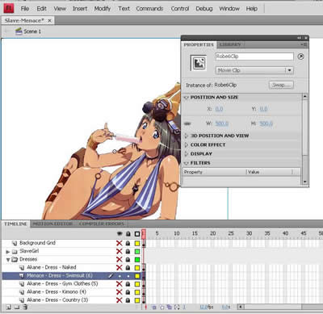

Click the magnet link and lock it down. Now remember those numbers we put in the cheat sheet. 7X5 is the screen offset or border. And the screen size is 448x336 position at will. Rinse and repeat for the rest of the dresses. Were done for the .fla file lets go look at the .as programing side.

Part 4 adding Dresses in software.

To tell you the truth this is easy. We already have akane's and its basically changing flavor text. This is all covered very well in the SDK “Core – Item + Dress” ctrl-f SetDressDetails, go read it if you have any questions. While your here might as well change the name of the slave from akane to your slave.

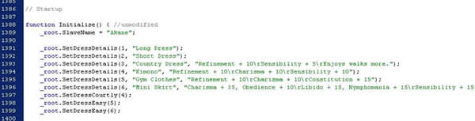

_root.SetDressDetails(5, "Gym Clothes", "Refinement + 10\rCharisma + 10\rConstitution + 15");

_root.SetDressDetails(Dress number in order, “Dress Name”, “Stats”);

You can also set dress details. There's a whole list in the SDK.

_root.SetDressCourtly(4);
_root.SetDressEasy(5);

for menace were definitely going to set that dress as

_root.SetDressSwimsuit(6);
_root.SetDressEasy(6);

As an extra note “\r” is a new line we will get to that in a later chapter.

Now we go set the stats. Pull out your cheat sheet again for where the points should be and have at it. Add on the wear dress, subtract on the remove dress.

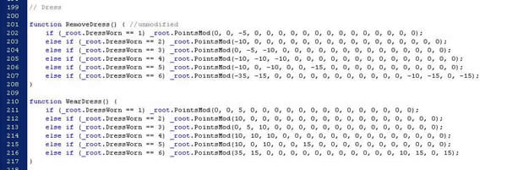

Were done for now. I know your probably saying that we should still do leashes, collars, and halos but I guarantee your going to modify one of those images before your done and changing them over and over will be rather frustrating. So that is the last thing we should do.

Now remember “on/off/on/on/off/off” that I said I would explain earlier. It's the layers that need to be visible and hidden for the compile to work, otherwise it will turn into a rather large disaster, with either everything being displayed or nothing being displayed.

One last thing we have to do before compiling, turning the frames on and off. Remember that on/off/on/on/off/off in your cheat sheet. That's how the layers have to be visible, for the Slave Maker to compile the pictures correctly.
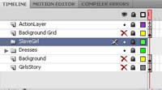

Lesson 3 will be on variables and images.

